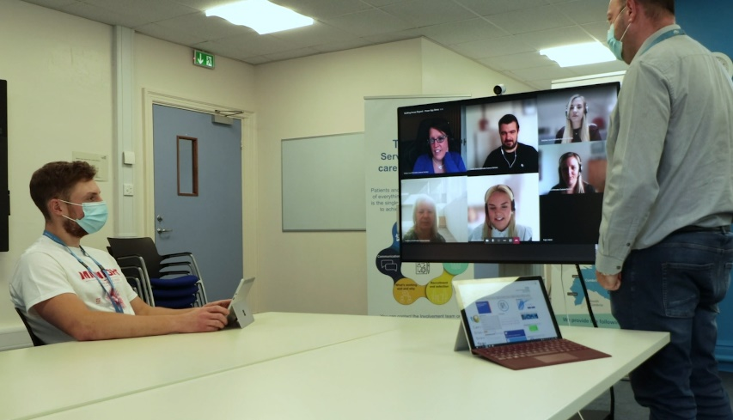
Microsoft Teams for collaboration between healthcare and public sector

Use Teams to collaborate

Dear all,
More and more colleagues are using Microsoft Teams to collaborate with the public sector. They shared some feedback with <name of the change lead or change team> to say that this allows them to:
- be more flexible as they can join meetings remotely from any location
- connect more easily with local councils, social workers, care providers and other partners
- have a clear and joint-up picture of the individuals they are supporting
- make better decisions thanks to increased attendance
- encourage knowledge sharing between healthcare and social care professionals

We wanted to let you know because this may be a great time-saver for you as well. There are a few quick links for you below to get started if you are using Teams for the first time. If you want to know more about how to use Teams to collaborate with the public sector, look at the learning content on <link to NHS support net location>.

We hope this is useful.
Kind regards.
<Your name>
PLEASE DELETE THIS BAR BEFORE SENDING
This email template is designed for you to send to your peers and team members. Please customise the areas highlighted in grey below.
Getting started
Get Started with Teams »
Explore training resources »

Get the app
Microsoft Teams is available as a desktop app and as a mobile app for iOS and Android Download apps ».
You can also run Microsoft Teams as a web app: go to https://teams.microsoft.com.

See what you can do with Microsoft Teams

Go to www.aka.ms/MicrosoftTeams
For additional guidance, tutorials and tips visit
www.successwithteams.com

